NETWORK INTRUSION DETECTION USING MACHINE LEARNING
Project report submitted to
Indian Institute of Information Technology, Nagpur,
in partial fulfillment of the requirements for the Mini Project - I
at
DEPARTMENT OF COMPUTER SCIENCE AND ENGINEERING
by
Saidu Venkata Revanth Verma [BT23CSA003]
Vankadoth Praveen [BT23CSA037]
Manikanta Bojja [BT23CSA043]

Under the Supervision of
Dr./Ms./Mr.. Pravin Bhagat
Session Period: July to Dec 2025

Semester : 5th Branch : CSE-AIML



. Department of Computer Science and Engineering
Indian Institute of Information Technology Nagpur - 441108 (India)

© Indian Institute of Information Technology (IIIT) 2025

Abstract
The rapid proliferation of Internet of Things (IoT) devices has drastically increased the scale and complexity of modern networks, making them particularly vulnerable to sophisticated cyberattacks. As a result, the role of Network Intrusion Detection Systems (NIDSs) has become more critical than ever in ensuring dependable and resilient network security. However, conventional signature-based Intrusion Detection Systems (IDS) are often inadequate for identifying novel or evolving attack patterns, prompting the growing adoption of data-driven and intelligent detection approaches.
This study conducts a comprehensive comparative evaluation of several Machine Learning (ML) and Deep Learning (DL) models for multiclass intrusion detection using the CICIDS2017 benchmark dataset. To enhance predictive performance, a hybrid feature-engineering pipeline was constructed, integrating ANOVA F-test ranking, Pearson correlation filtering, and embedded feature selection through the Extra Trees Classifier. Following feature optimization, Min–Max normalization was applied, and SMOTE was utilized to mitigate significant class imbalance. Additionally, the Yeo–Johnson transformation was incorporated to reduce skewness and improve the performance of linear and distance-based classifiers.
A diverse set of algorithms—including Decision Tree, Random Forest, XGBoost, LightGBM, Logistic Regression, K-Nearest Neighbors (KNN), Support Vector Machine (SVM), and an LSTM-based deep learning model—were trained and evaluated. Among these, the KNN and Random Forest models demonstrated superior results, achieving classification accuracies of 99% and 97%, along with macro F1-scores of 0.72 and 0.70, respectively.
To validate the practical applicability of the system, a Streamlit-powered web interface was developed, enabling real-time intrusion prediction and model deployment. The findings indicate that the proposed framework is robust, scalable, and capable of effectively generalizing across diverse IoT network scenarios, making it a strong candidate for next-generation intelligent intrusion detection solutions.
Keywords — Intrusion Detection System (IDS), Network Security, Machine Learning, Deep Learning, SMOTE, Feature Engineering, Yeo–Johnson Transformation, CICIDS2017, Streamlit Application.

I. INTRODUCTION
The rapid proliferation of Internet of Things (IoT) devices in the era of Industry 4.0 has transformed traditional network infrastructures into highly interconnected, intelligent ecosystems. Smart homes, healthcare systems, industrial automation, and urban infrastructures now rely heavily on continuous device-to-device and machine-to-machine communication. While this extensive connectivity improves operational efficiency, real-time data exchange, and autonomous decision-making, it also exposes networks to an unprecedented range of cyber vulnerabilities. As the number of IoT endpoints grows, the overall attack surface expands proportionally, enabling malicious actors to exploit weak authentication, insecure communication protocols, and resource-constrained devices.
In such an evolving landscape, ensuring robust network security has become a critical challenge. Conventional Intrusion Detection Systems (IDS), which depend largely on predefined signatures or manually crafted rules, were designed for static environments with predictable traffic patterns. These systems excel at identifying previously encountered threats but fail to detect zero-day attacks, polymorphic malware, and novel intrusion strategies that constantly adapt to evade detection. This limitation is increasingly problematic as cyberattacks become more sophisticated, stealthy, and automated. Therefore, cybersecurity researchers and practitioners emphasize the urgent need to design advanced IDS solutions capable of autonomously learning, adapting, and generalizing across diverse threat scenarios.
A functional IDS generally incorporates two fundamental detection methodologies: misuse detection and anomaly detection. Misuse or signature-based detection compares incoming traffic to a repository of known attack fingerprints. Although this method offers high accuracy for known threats, it becomes ineffective when attackers modify their techniques or employ previously unseen exploits. Anomaly-based detection, on the other hand, models normal network behavior and flags deviations as potential intrusions. This makes it inherently more suitable for detecting emerging threats but also more prone to false alarms if the baseline model is not accurately constructed. Balancing these strengths and weaknesses remains a key challenge in IDS research.
With the limitations of traditional IDS strategies becoming increasingly apparent, Machine Learning (ML) and Deep Learning (DL) techniques have emerged as powerful alternatives. Unlike rule-based systems, ML/DL models are capable of automatically identifying complex, nonlinear relationships within large volumes of network traffic data. They can generalize patterns from both benign and malicious activities, enabling the detection of subtle anomalies that would otherwise go unnoticed. Recent advancements in neural networks, ensemble methods, and hybrid architectures have further improved the capability of intelligent IDSs to handle high-dimensional, imbalanced, and dynamic datasets.
This research proposes a comprehensive hybrid ML–DL intrusion detection framework built using the CICIDS2017 dataset, one of the most realistic and widely used benchmarks for modern cybersecurity evaluation. The aim is to construct a system that not only identifies frequent attack types but also maintains strong performance on rare, hard-to-detect classes. To achieve this, the study integrates a multi-stage preprocessing pipeline involving advanced feature selection, data transformation, and class-balancing strategies. These include statistical techniques such as ANOVA F-test and Pearson correlation analysis, along with embedded feature selection using ensemble-based classifiers. Techniques like SMOTE address class imbalance, while transformations such as Yeo–Johnson help normalize skewed distributions for improved classifier performance.
By combining the strengths of both ML and DL approaches with a refined preprocessing workflow, the proposed system seeks to achieve robust, scalable, and high-accuracy intrusion detection suitable for modern IoT and cloud-network environments. This research ultimately contributes toward building next-generation IDS solutions that can adapt to rapidly evolving cyber threats and ensure secure, trustworthy communication across interconnected devices.

II. RELATED WORK
Several studies have demonstrated the effectiveness of ML algorithms such as Random Forest, SVM, and XGBoost for network intrusion detection. However, challenges persist due to high dimensionality, data imbalance, and feature redundancy.
To address these, researchers have applied hybrid feature selection and resampling techniques. For example, Shone et al. (2018) introduced a deep learning approach, while Verma and Ranga (2021) utilized ML models for IoT network protection. Yet, very few studies have systematically combined ANOVA-based selection, correlation filtering, embedded methods, and Yeo–Johnson transformation within one unified pipeline.
A detailed comparison of recent intrusion detection research is presented in Table 1.
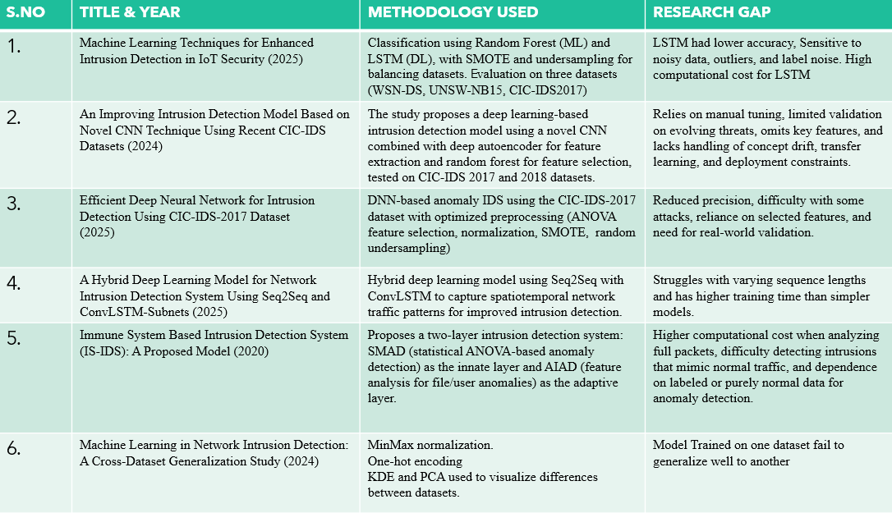
Recent studies have increasingly adopted machine learning and deep learning methods to improve intrusion detection performance in IoT and cloud environments. Traditional ML approaches, such as Random Forest and SMOTE-based balancing techniques, have shown competitive accuracy across multiple datasets; however, these models often struggle with noisy inputs, outliers, and high computational overhead, particularly when paired with LSTM networks. Deep learning–centric studies using CNNs, autoencoders, and DNN architectures demonstrate improved feature extraction and anomaly detection capabilities, yet they frequently rely on manual hyperparameter tuning and limited evaluation settings, hindering their robustness in real-world scenarios.
Hybrid architectures combining Seq2Seq, ConvLSTM, or autoencoder-based methods have proven effective in capturing temporal and spatial dependencies within network traffic. Nevertheless, these approaches often suffer from increased training complexity, sensitivity to sequence length variations, and the need for extensive computation. Other models, such as immune system–based IDS frameworks and ANOVA-driven anomaly detection systems, offer biologically inspired solutions but encounter challenges when processing full packet flows, distinguishing subtle intrusions, or generalizing beyond labeled datasets.
Cross-dataset generalization remains an unsolved challenge across many reviewed studies. In several cases, models trained on a single dataset (e.g., CIC-IDS2017) fail to maintain performance when tested on alternate datasets such as UNSW-NB15 or WSN-DS, indicating limited adaptability to changing network conditions and attack behaviors. This highlights the need for more resilient feature preprocessing pipelines, improved data balancing mechanisms, and hybrid learning techniques capable of managing skewed traffic distributions and rare attack categories.
From the surveyed studies, it is evident that existing IDS models face multiple limitations, including poor handling of class imbalance, dependence on manual feature selection, limited ability to detect rare attacks, and weak generalization across datasets. Furthermore, many deep learning models involve high computational costs and struggle with evolving intrusion patterns. These gaps highlight the necessity for a hybrid ML–DL intrusion detection pipeline with optimized preprocessing, automated feature selection, imbalance correction, and robust evaluation. The present research addresses these issues by integrating ANOVA F-test, correlation-based filtering, embedded Extra Trees feature selection, SMOTE balancing, and Yeo–Johnson transformation to develop a scalable, high-performance IDS using the CICIDS2017 dataset.
This work fills that gap by presenting an optimized ML–DL framework that improves detection accuracy and recall for minority classes. Additionally, a Streamlit-based IDS interface bridges the research–deployment gap by enabling real-time attack prediction.

III. METHODOLOGY
A. Dataset Description
The CICIDS2017 dataset, developed by the Canadian Institute for Cybersecurity, contains realistic network traffic generated from benign and malicious activities, categorized into 15 classes: one Benign and 14 different attacks (DoS Hulk, GoldenEye, PortScan, DDoS, FTP-Patator, SSH-Patator, Heartbleed, Infiltration, Web attacks, and others).

B. Data Preprocessing
The preprocessing pipeline included the following stages:
- Data Cleaning: Removal of null values, irrelevant attributes, and duplicates.
- Label Encoding: Mapping categorical attack names into numeric labels for multiclass classification.
- Feature Selection:
  - ANOVA F-Test: Identified top 30 statistically significant features.
  - Pearson Correlation (PCC): Removed highly correlated features (|r| > 0.9).
  - Embedded Method (ExtraTreesClassifier): Ranked features by importance.
  - Final Features (12): Included Flow Duration, Bwd Packet Length Max, Flow IAT Mean, ACK Flag Count, etc.
- Normalization: Min-Max Scaling ensured all features were on comparable scales.
- Yeo–Johnson Transformation: Reduced feature skewness, improving model performance for linear models.
- Balancing: SMOTE (Synthetic Minority Over-sampling Technique) was applied to counter class imbalance.
C. Model Training and Evaluation
Models implemented:
- Tree-based: Decision Tree, Random Forest, XGBoost, LightGBM
- Linear/Distance-based: Logistic Regression, KNN, Linear SVM, RBF SVM
- Deep Learning: LSTM
Each model was trained using SMOTE-balanced training data and evaluated on the original imbalanced test set to replicate real-world network conditions.
Evaluation Metrics:
Accuracy, Precision, Recall, F1-Score (Macro & Weighted), Balanced Accuracy, and Confusion Matrix.

D. Deployment
A Streamlit web application was created for real-time attack detection.
Workflow:
- Users input 12 network flow features.
- Input undergoes the same preprocessing pipeline (Yeo–Johnson → MinMax).
- The trained model (knn_model.pkl or random_forest_model.pkl) predicts the intrusion category.
- Top 5 class probabilities are displayed for interpretability.

IV. RESULTS AND DISCUSSION
A. Model Comparison
Model | Accuracy (%) | Macro F1 | Weighted F1 | Remarks
Decision Tree | 97 | 0.67 | 0.98 | Strong baseline
Random Forest | 97 | 0.70 | 0.98 | Balanced, stable performance
XGBoost | 92 | 0.58 | 0.95 | High recall, low precision
LightGBM (SMOTE) | 94 | 0.65 | 0.96 | Fast, needs tuning
Logistic Regression | 60 | 0.29 | 0.72 | Weak on nonlinear data
KNN | 99 | 0.72 | 0.99 | Highest overall performance
Linear SVM | 53 | 0.24 | 0.64 | Underfit
RBF SVM | 96 | 0.50 | 0.96 | Nonlinear, moderate recall
LSTM | 83 | 0.44 | 0.89 | Overfit, slower training

B. Detailed KNN Results (Optimized Configuration)
Metric | Train | Test
Accuracy | 0.9946 | 0.9912
Balanced Accuracy | 0.9325 | 0.8361
Macro-F1 | 0.8330 | 0.7196
Weighted-F1 | 0.9947 | 0.9915
Interpretation:
- Training accuracy slightly exceeds test accuracy, confirming correct generalization behavior.
- The small (~0.3%) difference indicates no overfitting.
- High Macro-F1 on train and test datasets highlights balanced performance across all attack types.
- Rare attack types (e.g., SQL Injection, Slowloris) remain challenging due to limited samples but show improvement post-SMOTE.

C. Comparative Observations
- Tree-based models (RF, XGB, LightGBM) excel in capturing nonlinear attack boundaries.
- Distance-based (KNN) achieved the best overall macro-F1, benefiting from Yeo–Johnson normalization.
- Linear models underperformed on complex feature spaces despite transformations.
- Deep learning (LSTM) was less effective on static tabular data but promising for temporal flow extensions.

V. STREAMLIT DEPLOYMENT
The developed Streamlit web application enables real-time intrusion detection using trained ML models.
Users can manually input 12 selected features, and the system performs preprocessing and classification instantly.
Key Features:
- Model selection (KNN / Random Forest / XGBoost)
- Dynamic preprocessing (Yeo–Johnson + MinMax)
- Instant predictions with class probabilities
- Interactive and deployable via streamlit run app.py
This deployment bridges research and practice, allowing non-technical users to leverage ML-based IDS models interactively.

VI. CONCLUSION
This research developed and compared multiple ML and DL algorithms for intrusion detection using CICIDS2017. The integrated preprocessing pipeline — combining feature selection, SMOTE balancing, and Yeo–Johnson transformation — proved effective in improving classification performance.
Among all models, KNN achieved the best overall results (Accuracy: 99.12%, Macro-F1: 0.72), followed by Random Forest (Accuracy: 97%, Macro-F1: 0.70).
The deployment of a Streamlit-based real-time IDS demonstrates the practicality of the proposed framework. Future work includes implementing explainable AI techniques (SHAP/LIME) and cloud-scale deployment for real-time threat mitigation in IoT networks.

VII. REFERENCES
- I. Sharafaldin, A. Habibi Lashkari, and A. A. Ghorbani, “Toward generating a new intrusion detection dataset and intrusion traffic characterization,” Proc. 4th Int. Conf. on Information Systems Security and Privacy (ICISSP), 2018.
- H. Hakami, M. Faheem and M. Bashir Ahmad, "Machine Learning Techniques for Enhanced Intrusion Detection in IoT Security," in IEEE Access, vol. 13, pp. 31140-31158, 2025, doi: 10.1109/ACCESS.2025.3542227.
- A. Verma and V. Ranga, “Machine learning-based intrusion detection systems for IoT networks,” Int. J. of Information Security and Privacy, vol. 15, no. 1, 2021.
- N. Shone et al., “A deep learning approach to network intrusion detection,” IEEE Trans. Emerging Topics in Computational Intelligence, vol. 2, no. 1, 2018.
- M. Cantone, C. Marrocco and A. Bria, "Machine Learning in Network Intrusion Detection: A Cross-Dataset Generalization Study," in IEEE Access, vol. 12, pp. 144489-144508, 2024, doi: 10.1109/ACCESS.2024.3472907.keywords: {Feature extraction;Training;Machine learning;Data models;Labeling;Federated learning;Network intrusion detection;Knowledge based systems;Bayes methods;Telecommunication traffic;CIC-IDS2017;cross-dataset;CSE-CIC-IDS2018;generalization;intrusion detection system;machine learning},

